Abinash Satapathy

Reg. no.: 16BCE0081

**CSE3020 – Data Visualisation**

**Slot: C1**

**Faculty: Lydia Jane G**

**Visualisation of Global Temperature using R**

1. **Dataset details**
2. URL: <https://www.kaggle.com/berkeleyearth/climate-change-earth-surface-temperature-data/downloads/climate-change-earth-surface-temperature-data.zip/2>
3. No. of attributes = 7

No. of rows = 239, 178

1. Attributes definition:

|  |  |
| --- | --- |
| Date | The date whose temperature is included in the dataset |
| Average temperature | The mean temperature for that day |
| Uncertainty in calculation | The error amount in calculation of the temperature |
| City | Place whose temperature is taken into consideration |
| Country | The country where the place is situated |
| Latitude | The angular distance of a place north or south of the earth's equator |
| longitude | The angular distance of a place east or west of the Greenwich meridian |

1. **Data Abstraction**

|  |  |
| --- | --- |
| Date | Quantitative |
| Average temperature | Quantitative |
| Uncertainty in calculation | Quantitative |
| City | Qualitative (nominal) |
| Country | Qualitative (nominal) |
| Latitude | Quantitative |
| longitude | Quantitative |

1. **Task Abstraction**
2. Potential questions that can be asked by looking at the dataset
3. What is the average temperature of a month of all the cities of a country during a particular year range?
4. What is the year-wise average of different cities of a country?
5. What are the peak temperatures of a set of cities?
6. What is the temperature rise/fall over a wide range of years (like 50 to 100 years range)?
7. Which country has the highest mean temperature for a specific month?
8. Which country has the highest range of mean temperatures?
9. What is the range of latitudes where the mean temperature is greater than some ‘x’ value?
10. Is climate change really happening?
11. What is the annual increase/decrease of the mean temperature of a country?
12. What is the difference pattern of temperature differences between mean temperature of a city and human body, where 37°C is the normal temperature of a human body?
13. Attributes required for answering the above questions and others as well
14. The Average Temperature attribute is the most important numerical data in the dataset. So, usually all the queries will include the temperature data.
15. The city attribute is important for questions targeted to a particular city or a set of cities.
16. The country attribute is of equal importance as the city, as it helps in getting patterns on a global scale.

The actions that would be performed mostly are:

* Plotting the temperature
* Calculating the range of mean temperatures by Highest – Lowest formula
* Standard deviation formula might be used in case a query regarding that is asked.

$$SD= \sqrt{\frac{\sum{{|x-x̄|}^{2}}}{n}}$$

1. **Encoding**
2. Appropriate encoding techniques
3. Jitter plot
4. Line graph
5. Heat map
6. Density plot
7. Scatterplot
8. Example graphs for analysis of certain questions
9. ClimateCityIndia %>% filter(Year==1904 | Year==2004) %>% ggplot(aes(AverageTemperature,Month,color=AverageTemperature)) + geom_quasirandom() + scale_colour_viridis() + facet_grid(Year ~.) + coord_flip()

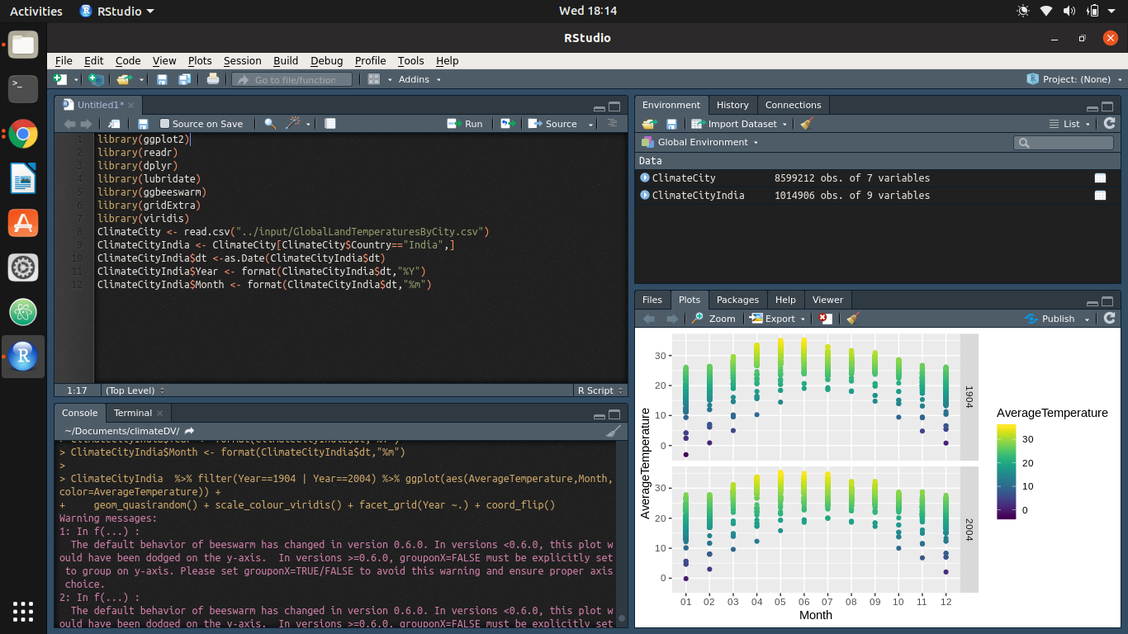

1. ClimateCityIndia %>% filter( Year==1854 | Year==1900 | Year==1950 | Year==2004) %>% ggplot(aes(AverageTemperature,Year,color=AverageTemperature)) + geom_quasirandom() + scale_colour_viridis(option = "C")

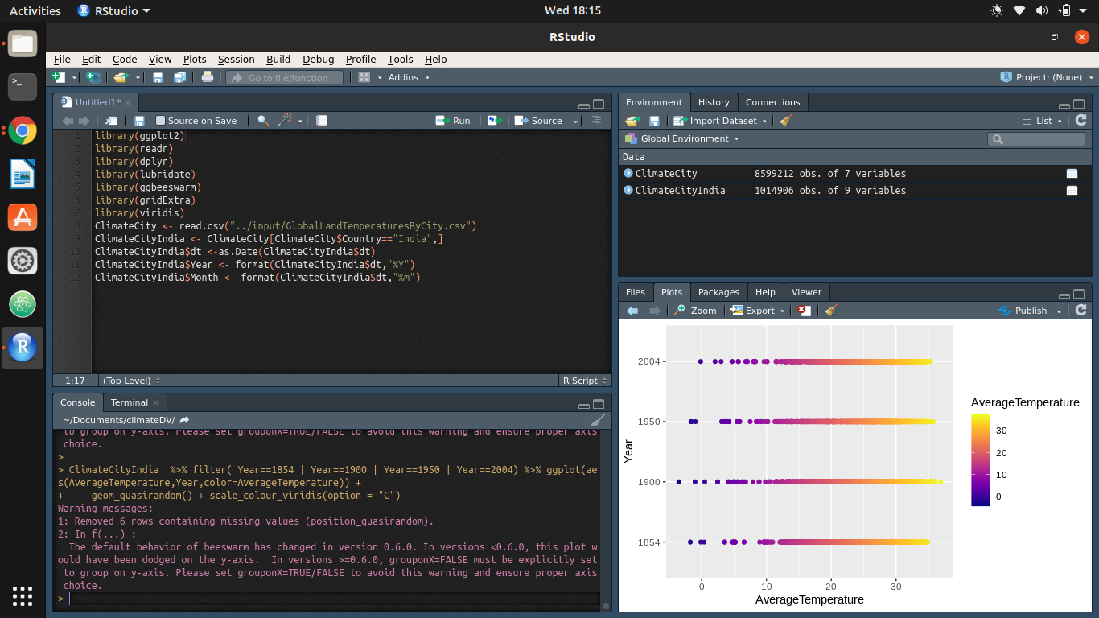

1. Major_Cities<- c("Madras","Hyderabad", "Bombay", "Bangalore" , "Delhi" ,"Calcutta","Guwahati","Kochi")

df <- ClimateCityIndia %>% filter(City %in% Major_Cities)

ggplot(df,aes(AverageTemperature,label=paste(City,""))) + geom_density(fill="gray20") + facet_grid(City ~.) + ylab("") + geom_text(aes(0,0.2),family="Ubuntu Condensed",fontface="plain",hjust=0.1,color="gray20") + theme_minimal() + ggtitle("Density plot of average temperatures") + theme(text = element_text(family = 'Ubuntu Condensed', face = 'plain', color = '#3A3F4A'), axis.text.y = element_blank(), axis.ticks.y = element_blank(), axis.line.y = element_blank(), strip.background = element_blank(), strip.text.y = element_blank(), axis.line.x = element_blank(), plot.background = element_rect(fill = "#EFF2F4"), plot.title = element_text(size = 14, face = "bold", colour = "gray20", vjust = -1))

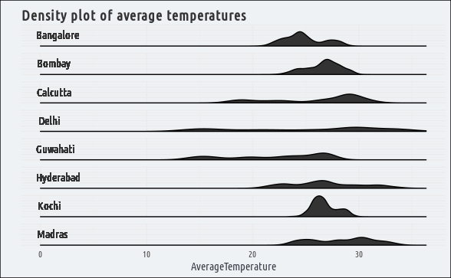

1. Major_Cities<- c("Madras","Hyderabad", "Bombay", "Bangalore" , "Delhi" ,"Calcutta","Guwahati","Shillong","Surat","Warangal")

ClimateCityIndia %>% filter(City %in% Major_Cities) %>% group_by(City,Year) %>% summarise(avg_temp= mean(AverageTemperature)) %>% ggplot(aes(Year,avg_temp,color=avg_temp)) + geom_point() + scale_x_discrete( breaks = c(1796,2013)) + theme_minimal(base_family = "Ubuntu Condensed") + scale_color_viridis(option="B") + theme(axis.text.x = element_text(angle = 90, hjust = 1), panel.spacing = unit(0.6, "lines"), legend.position = "top", legend.text=element_text(size=8), panel.grid.major.y = element_blank(), panel.grid.minor.y = element_blank(), axis.ticks.y = element_blank(), axis.ticks.x = element_blank(), plot.background = element_rect(fill = "#EFF2F4"), legend.key.height = unit(10, "pt"), legend.key.width = unit(70, "pt")) + ggtitle("Temperature Change over the last two centuries",subtitle = "Indian Cities") + ylab("Temperature")+labs(color="Temperature") + facet_grid(~City )

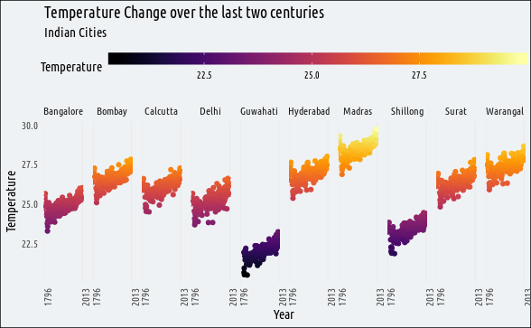

1. ClimateCityIndia %>% filter(City %in% Major_Cities) %>% group_by(City,Month) %>% summarise(avg_temp = mean(AverageTemperature, na.rm=T)) %>% ggplot(aes(Month, reorder(City, avg_temp), fill=avg_temp)) + geom_tile() + scale_fill_viridis(option = "C") + theme_minimal(base_family = "Ubuntu Condensed")+ labs(fill= "Temperature ")+ ylab("") + theme(panel.grid= element_blank()) + ggtitle("Heatmap!",subtitle = "Cities,Months and Temperature")

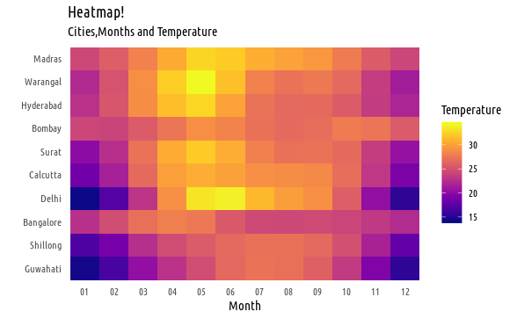

1. Average Temperature in India

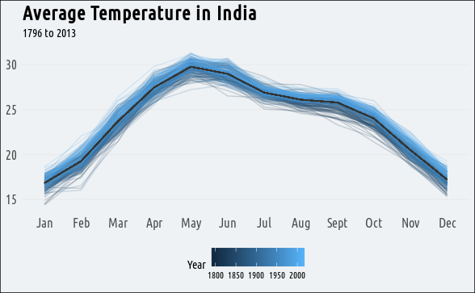

library(ggplot2)

library(readr)

library(dplyr)

library(RColorBrewer)

library(gganimate)

India <- ClimateCountry %>% filter(Country=="India")

India$dt <-as.Date(India$dt)

India$Year <- format(India$dt,"%Y")

India$Month <- format(India$dt,"%m")

India %>% filter(!is.na(AverageTemperature)) %>%

filter(Year > 1850) %>%

group_by(Year) %>% mutate(no_of_cases= length(Year)) %>%

group_by(Month) %>%

mutate(avg_tempMonth= mean(AverageTemperature)) %>%

filter(no_of_cases==12) %>%

ggplot(aes(Month,AverageTemperature,group=Year,cumulative = TRUE,alpha=Year,label=Year,frame=Year)) +

geom_line(color="grey20") +

geom_line(aes(Month,avg_tempMonth,frame= 2013 + as.numeric(Month) , group=1),size= 2.3,color= "dodgerblue3") +

#geom_text(aes(x=06,y=20,cumulative=FALSE),size=30,color="grey20") +

theme_minimal(base_family = "Ubuntu Condensed")+

scale_x_discrete(labels=c("Jan","Feb","Mar","Apr","May","Jun","Jul","Aug","Sept","Oct","Nov","Dec"))+

theme(legend.position = "none",axis.title = element_blank(),

panel.grid.major.x = element_blank(),

panel.grid.minor.x = element_blank(),

panel.grid.minor.y = element_blank(),

plot.background = element_rect(fill = "#EFF2F4"),

axis.text = element_text(size = 12),

plot.title = element_text(size=18,face = "bold")) +

ggtitle("Average Temperature in India",subtitle = "1850 to 2013") +

labs(caption= "Vamsi Krishna \t Source: Kaggle")

p<-

India %>% filter(!is.na(AverageTemperature)) %>%

filter(Year > 1850) %>%

group_by(Year) %>% mutate(no_of_cases= length(Year)) %>%

group_by(Month) %>%

mutate(avg_tempMonth= mean(AverageTemperature)) %>%

filter(no_of_cases==12) %>%

ggplot(aes(Month,AverageTemperature,group=Year,cumulative = TRUE,alpha=Year,label=Year,frame=Year)) +

geom_line(color="grey20") +

geom_line(aes(Month,avg_tempMonth,frame= 2013 + as.numeric(Month) , group=1),size= 2.3,color= "dodgerblue3") +

geom_text(aes(x=06,y=20,cumulative=FALSE),size=30,color="grey20") +

theme_minimal(base_family = "Ubuntu Condensed")+

scale_x_discrete(labels=c("Jan","Feb","Mar","Apr","May","Jun","Jul","Aug","Sept","Oct","Nov","Dec"))+

theme(legend.position = "none",axis.title = element_blank(),

panel.grid.major.x = element_blank(),

panel.grid.minor.x = element_blank(),

panel.grid.minor.y = element_blank(),

plot.background = element_rect(fill = "#EFF2F4"),

axis.text = element_text(size = 12),

plot.title = element_text(size=18,face = "bold")) +

ggtitle("Average Temperature in India",subtitle = "1850 to 2013") +

labs(caption= "Vamsi Krishna \t Source: Kaggle")

gganimate(p,"Output.gif",ani.width=810, ani.height=520, interval=0.1,title_frame = F)

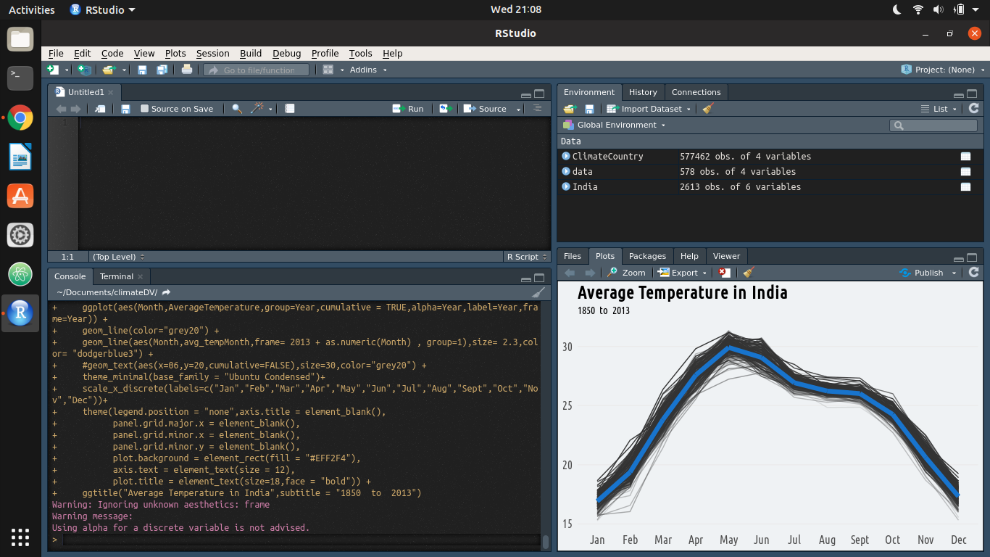



It is a gif.

library(sp)

library(maps)

library(raster)

library(gstat)

library(geoR)

library(maptools)

library(GISTools)

library(animation)

#library(readr)

glt$O1 <- substr(glt$Longitude, nchar(glt$Longitude), nchar(glt$Longitude))

glt$O2 <- substr(glt$Latitude, nchar(glt$Latitude), nchar(glt$Latitude))

glt$Longitude <- ifelse(glt$O1 == "W",

-as.numeric(substr(glt$Longitude, 1, nchar(glt$Longitude)-1)),

as.numeric(substr(glt$Longitude, 1, nchar(glt$Longitude)-1)))

glt$Latitude <- ifelse(glt$O2 == "S",

-as.numeric(substr(glt$Latitude, 1, nchar(glt$Latitude)-1)),

as.numeric(substr(glt$Latitude, 1, nchar(glt$Latitude)-1)))

glt$Year <- substr(glt$dt, 1, 4)

glt.continent = data.frame(

Country = c(

"Algeria","Angola","Benin","Botswana","Burkina Faso","Burundi","Cameroon","Central African Republic","Chad","Congo","Congo (Democratic Republic Of The)","Côte D'Ivoire","Djibouti","Egypt","Equatorial Guinea","Eritrea","Ethiopia","Gabon","Gambia","Ghana","Guinea","Guinea Bissau","Kenya","Lesotho","Liberia","Libya","Madagascar","Malawi","Mali","Mauritania","Mauritius","Morocco","Mozambique","Namibia","Niger","Nigeria","Reunion","Rwanda","Senegal","Sierra Leone","Somalia","South Africa","Sudan","Swaziland","Tanzania","Togo","Tunisia","Uganda","Zambia","Zimbabwe","Afghanistan","Bahrain","Bangladesh","Burma","Cambodia","China","Hong Kong","India","Indonesia","Iran","Iraq","Israel","Japan","Jordan","Kazakhstan","Laos","Lebanon","Malaysia","Mongolia","Nepal","Oman","Pakistan","Philippines","Qatar","Russia","Saudi Arabia","Singapore","South Korea","Sri Lanka","Syria","Taiwan","Tajikistan","Thailand","Turkey","Turkmenistan","United Arab Emirates","Uzbekistan","Vietnam","Yemen","Albania","Armenia","Austria","Azerbaijan","Belarus","Belgium","Bosnia And Herzegovina","Bulgaria","Croatia","Cyprus","Czech Republic","Denmark","Estonia","Finland","France","Georgia","Germany","Greece","Hungary","Iceland","Ireland","Italy","Latvia","Lithuania","Macedonia","Moldova","Montenegro","Netherlands","Norway","Poland","Portugal","Romania","Serbia","Slovakia","Slovenia","Spain","Sweden","Switzerland","Ukraine",

#"United Kingdom",

"UK",

"Bahamas","Canada","Costa Rica","Cuba","Dominican Republic","El Salvador","Guatemala","Haiti","Honduras","Jamaica","Mexico","Nicaragua","Panama","Puerto Rico",

#"United States",

"USA",

"Australia","New Zealand","Papua New Guinea","Argentina","Bolivia","Brazil","Chile","Colombia","Ecuador","Guyana","Paraguay","Peru","Suriname","Uruguay","Venezuela"

),

Continent = c(

"Africa","Africa","Africa","Africa","Africa","Africa","Africa","Africa","Africa","Africa","Africa","Africa","Africa","Africa","Africa","Africa","Africa","Africa","Africa","Africa","Africa","Africa","Africa","Africa","Africa","Africa","Africa","Africa","Africa","Africa","Africa","Africa","Africa","Africa","Africa","Africa","Africa","Africa","Africa","Africa","Africa","Africa","Africa","Africa","Africa","Africa","Africa","Africa","Africa","Africa","Asia","Asia","Asia","Asia","Asia","Asia","Asia","Asia","Asia","Asia","Asia","Asia","Asia","Asia","Asia","Asia","Asia","Asia","Asia","Asia","Asia","Asia","Asia","Asia","Asia","Asia","Asia","Asia","Asia","Asia","Asia","Asia","Asia","Asia","Asia","Asia","Asia","Asia","Asia","Europe","Europe","Europe","Europe","Europe","Europe","Europe","Europe","Europe","Europe","Europe","Europe","Europe","Europe","Europe","Europe","Europe","Europe","Europe","Europe","Europe","Europe","Europe","Europe","Europe","Europe","Europe","Europe","Europe","Europe","Europe","Europe","Europe","Europe","Europe","Europe","Europe","Europe","Europe","Europe","North America","North America","North America","North America","North America","North America","North America","North America","North America","North America","North America","North America","North America","North America","North America","Oceania","Oceania","Oceania","South America","South America","South America","South America","South America","South America","South America","South America","South America","South America","South America","South America America"

))

glt.y <- aggregate(list(

AvgTemp = glt$AverageTemperature,

AvgTempUnc = glt$AverageTemperatureUncertainty

),

by = list(

Year = round(as.numeric(glt$Year) / 2) * 2,

Latitude = round(glt$Latitude / 2) * 2,

Longitude = round(glt$Longitude / 2) * 2),

FUN = mean, na.rm = TRUE

)

glt.y <- subset(glt.y, !is.na(glt.y$AvgTemp))

coordinates(glt.y) <- ~ Longitude + Latitude

get.countries <- function(continents, resolution) {

countries <- as.character(glt.continent[glt.continent$Continent %in% continents, ]$Country)

# Chose map

w <- map("world", fill = TRUE, plot = FALSE)

IDs <- sapply(strsplit(w$names, ":"), function(x) x[1])

w <- map2SpatialPolygons(w, IDs = IDs)

# Subsetting by countries

w <- w[names(w) %in% countries, ]

ext.bez <- extent(w)

xy <- abs(apply(as.matrix(bbox(ext.bez)), 1, diff))

r <- raster(ext.bez, ncol=xy[1], nrow=xy[2])

res(r) <- resolution

# Rasterize

ras <-rasterize(w, r)

ras <- as(ras, "SpatialPixels")

years <- unique(subset(glt.y@data, !is.na(AvgTemp))$Year) # No data for 1746?

ani.options(interval = 0.1)

saveGIF( {

sapply(years, function(x) {

d <- subset(glt.y, Year==x)

m <- "Average Land Temperature in Celsius"

#s <- seq(-5, 30, by=2.5)

idw <- krige(AvgTemp ~ 1, d, ras, block= c(100))

image(idw, xlab=x, asp=1, main=m)

sh <- shading(breaks = seq(0, 15, by=5), cols = heat.colors(5))

choro.legend(px = "bottomleft", sh = sh, bg = "white", cex = 0.75)

ani.pause()

})

},

movie.name = paste(paste(continents, collapse="_"), ".gif", sep = ""),

img.name = "Rplot",

convert = "convert",

ani.width = 800,

ani.height = 600)

plot(w, main = "The Grid")

points( glt.y[!is.na(over(glt.y, w)), ], pch=3)

}

get.countries(c("Europe", "Asia"), 0.3)



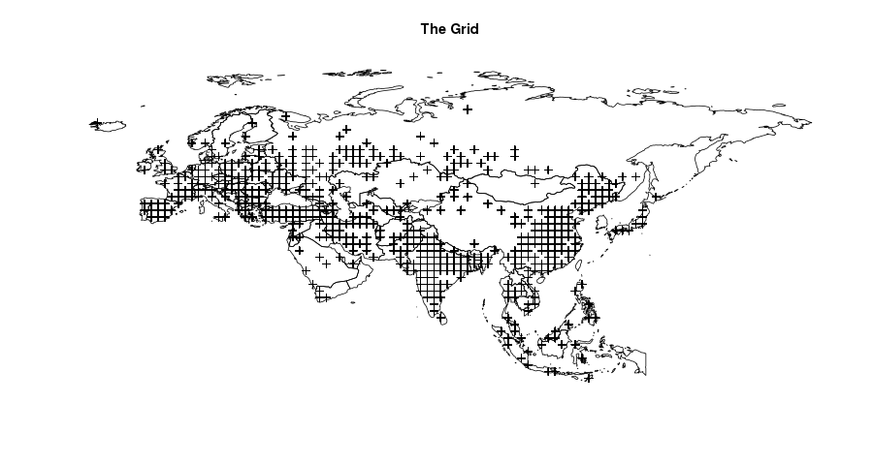

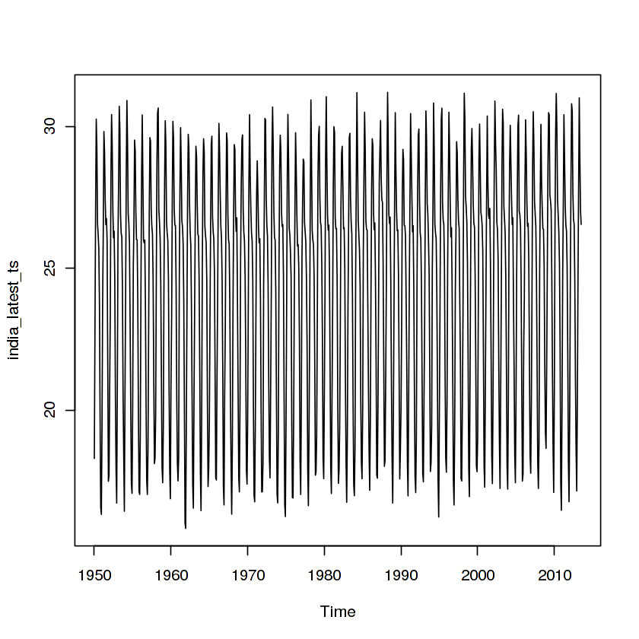

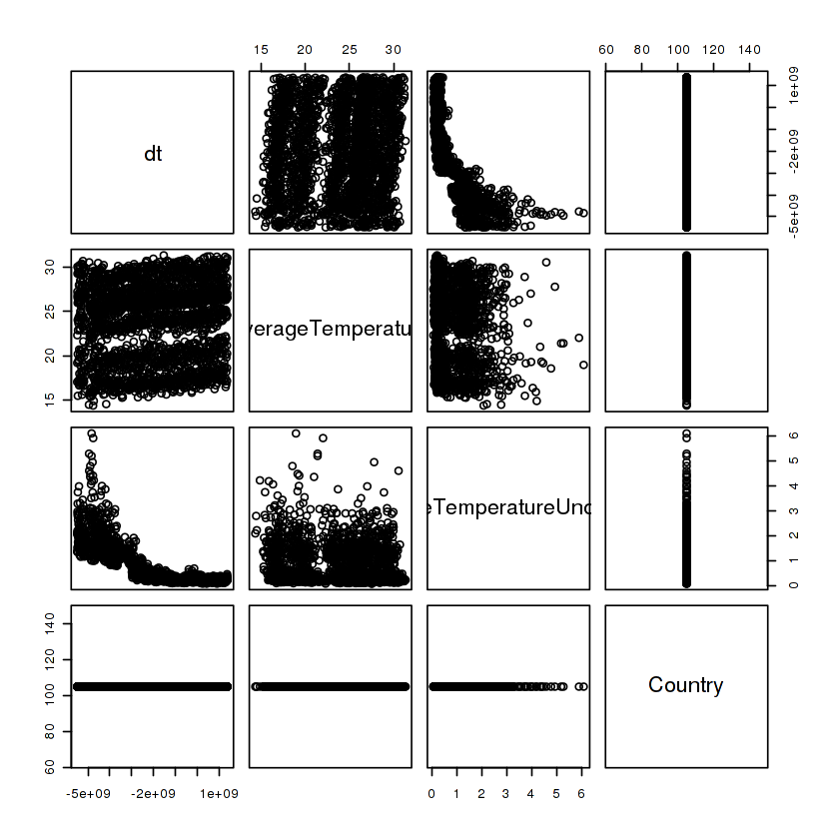





library(shiny)

library(plotly)

library(ggplot2)

library(ggthemes)

library(data.table) library(tidyr)

library('tidyr')

data <- read.csv('Data/GlobalLandTemperaturesByState.csv', TRUE,",")

head(data)

row.has.na <- apply(data, 1, function(x){any(is.na(x))})

sum(row.has.na)

data <- data[!row.has.na,]

data <- separate(data,col = dt, into = c("Year", "Month", "Day"), convert = TRUE)

data<- filter(data,Year>1930)

shinyServer(

function(input,output) {

output$myplot <- renderPlot( {

data_new <- filter(data,Country==input$plot_ctry)

data_new %>%

group_by(Year) %>%

summarise(Temp = mean(AverageTemperature)) -> data_new1

data_new <- filter(data,Country==input$plot_ctry)

data_new %>%

filter(Year>1930) %>%

group_by(Year) %>%

summarise(Temp = mean(AverageTemperature)) ->data_new1

qplot(Year,Temp, data=data_new1, main="Average Temperature 1930-2013",

geom=c("line","jitter","smooth"))+ aes(colour = Temp) +

scale_color_gradient(low="yellow", high="red")

})

}

)

